
Booking Form
For 2nd and subsequent bookings in 2026
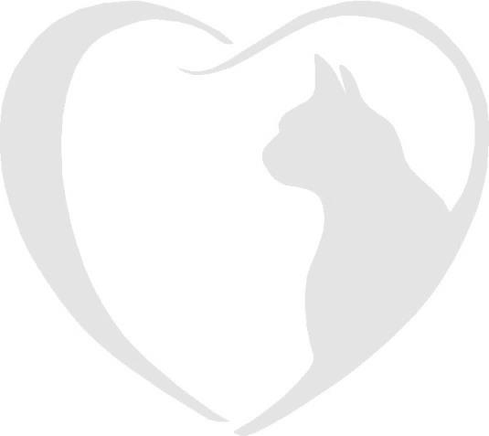

Brockhills Cattery, Brockhills Lane, New Milton, Hampshire. BH25 5QL
Phone : 07555 44 25 25
Email: gerard@brockhillscattery.co.uk

Booking Form
Please complete this form to confirm a reservation at Brockhills Cattery.
Owner’s full name
Drop off date Time
Collection date Time
Holiday Address
Holiday contact numbers
Local emergency contact
Name of Cats
Vaccination dates
Flea & worm treatments applied and date
Feeding preferences and additional information
Do you give consent to house your cats together and separate if necessary?
Veterinary Practice | Is your vet aware of your booking?
I have read and agree to the terms and conditions and consent to Fernhill Veterinary Clinic treating our cats if the need arises.

Signature Date

Important
Please remember your cat’s booster vaccinations must be up to date and to bring your Vaccination Card when you check in. We are unable to care for your cat without it.
Furthermore, please ensure your cat has had veterinary approved flea and worm treatment at least 7 days prior to your cat’s stay and inform us of the product used.

