
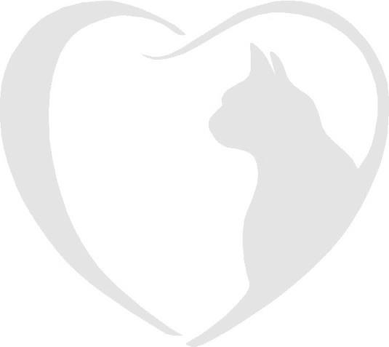
Master booking form
2026

Brockhills Cattery, Brockhills Lane, New Milton, Hampshire. BH25 5QL
Phone : 07555 44 25 25
Email: gerard@brockhillscattery.co.uk

Booking Form
Please complete this form to confirm a reservation at Brockhills Cattery.
Owner’s full name
Drop off date |  |  |  |  |  | Time
Collection date |  |  |  |  |  | Time
Address
Home contact numbers
Email Address
Holiday Address
Holiday contact numbers
Local Emergency contact (name, number and address)
Veterinary Practice Name
Address
Phone number |  |  |  |  |  | Is your vet aware of your booking?
Important
Please remember your cat’s booster vaccinations must be up to date and to bring your Vaccination Card when you check in. We are unable to care for your cat without it.
Furthermore, please ensure your cat has had veterinary approved flea and worm treatment at least 7 days prior to your cat’s stay and inform us of the product used.

Name of Cat 1 |  |  |  | Breed and colour
Age |  | Male | Female |  |  |  | Neutered | Insured
Vaccination date |  |  |  |  | Microchip number
Flea & worm treatments applied and date
Feeding preferences (special veterinary food/ amounts)
Medical requirements
Name of Cat 2 |  |  |  | Breed and colour
Age |  | Male | Female |  |  |  | Neutered | Insured
Vaccination date |  |  |  |  | Microchip number
Flea & worm treatments applied and date
Feeding preferences ( special veterinary food/ amounts)
Medical requirements
Do you give consent to house your cats together and separate if necessary?
Additional information which will enable your cat to have a pleasant stay.
If you wish to bring your cat’s favourite toy, bedding, scratching post etc. you are most welcome. Please ensure you cat is transported in a secure and escape proof container.

I have read and agree to the terms and conditions and consent to Fernhill Veterinary Clinic treating our cats if the need arises.

Signature Date

Occasionally we take photos for the website and social media; do you consent to photos of your cat being used?

