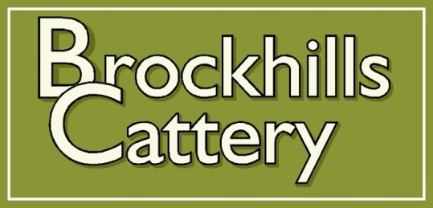

Booking Form

For 2nd and subsequent bookings in 2025

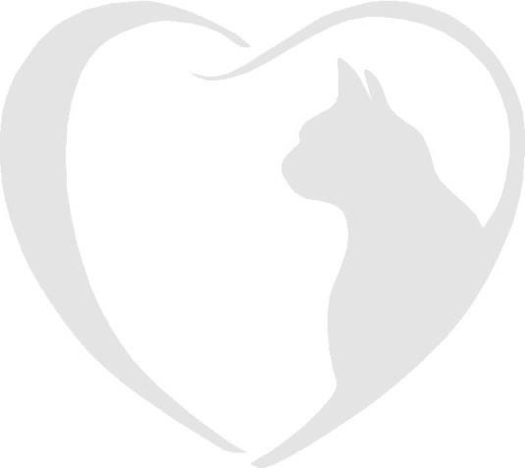

Brockhills Cattery, Brockhills Lane, New Milton, Hampshire. BH25 5QL

Phone : 07555 44 25 25

Email: gerard@brockhillscattery.co.uk

Booking Form

Please complete this form to confirm a reservation at Brockhills Cattery.

|  |  |
| --- | --- |
| Dates | |
| Owner’s full name | |
| Holiday Address | |
| Holiday contact numbers |  |
| Local emergency contact | |
| Name of Cats | |
| Vaccination dates | |
| Flea & worm treatments applied and date | |
| Feeding preferences and additional information | |
|  | |
|  | |
| Do you give consent to house your cats together and separate if necessary? | |
| Veterinary Practice | Is your vet aware of your booking? |
| I have read and agree to the terms and conditions and consent to Fernhill Veterinary Clinic treating our cats if the need arises.  Signature Date | |
| **Important**  Please remember your cat’s booster vaccinations must be up to date and to bring your Vaccination Card when you check in. We are unable to care for your cat without it.  Furthermore, please ensure your cat has had veterinary approved flea and worm treatment at least 7 days prior to your cat’s stay and inform us of the product used. | |