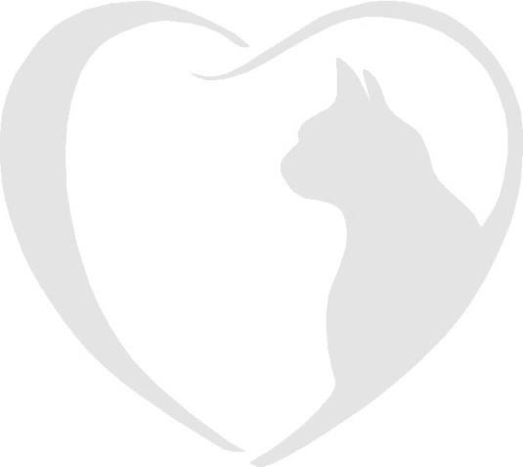

Brockhills Cattery, Brockhills Lane, New Milton, Hampshire. BH25 5QL
Phone : 07555 44 25 25
Email: gerard@brockhillscattery.co.uk

Booking Form
Please complete this form to request a reservation at Brockhills Cattery.
Dates
Owner’s full name
Address
Home contact numbers
Email Address
Holiday Address
Holiday contact numbers
Emergency contact (name and number)
Emergency contact 2 ( name and number)
Veterinary Practice Name
Address
Phone number |  |  |  |  |  | Is your vet aware of your booking?
Important
Please remember to have your cat’s booster vaccinations at least two weeks prior to coming to stay and bring your Vaccination Card when you check in. We are unable to care for your cat without it (licencing rules).
Furthermore, please ensure your cat has had veterinary approved flea and worm treatment at least 7 days prior to your cat’s stay and inform us of the product used.

Name of Cat 1 |  |  |  | Breed and colour
Age |  | Male | Female |  |  |  | Neutered | Insured
Vaccination date |  |  |  |  | Microchip number
Flea & worm treatments applied and date
Feeding preferences ( special veterinary food/ amounts)
Medical requirements
Name of Cat 2 |  |  |  | Breed and colour
Age |  | Male | Female |  |  |  | Neutered | Insured
Vaccination date |  |  |  |  | Microchip number
Flea & worm treatments applied and date
Feeding preferences ( special veterinary food/ amounts)
Medical requirements
Do you give consent to house your cats together and separate if necessary?
Additional information which will enable your cat to have a pleasant stay.
If you wish to bring your cat’s favourite toy, bedding, scratching post etc. you are most welcome. Please ensure you cat is transported in a secure and escape proof container.

I have read and agree to the terms and conditions in relation to this booking.

Signature Date

I have read and agree to the GDPR policy.

Signature Date

